Answer on Question #80312, Math / Algebra

Find all the asymptotes of the curve , where

**Solution**

At first we explore slant asymptotes of the curve. Let's write down the implicit equation in a look

Substituting the equation of the asymtote , we get

Equating coefficients at two senior members to zero, we find the asymptote’s parameters of *k* and *b*:

Thus the curve has the slant asymptote describing by the equation

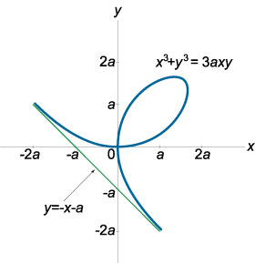

Figura 1

Let's check a possibility of existence of a vertical asymptote. We write its equation as . Let's substitute it in the initial implicit equation of a curve:

It means that the necessary condition of existence of a vertical asymptote is not satisfied. Therefore, the curve has only the slant asymptote found above.

**Answer:** the curve has the slant asymptote .

References:

1. http://www.math24.ru/асимптоты.html